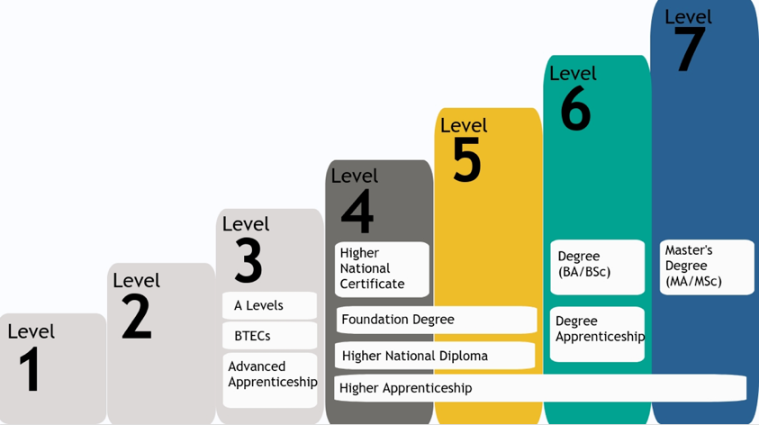

* During sixth form, you will be completing Level 3 qualifications, having already completed Level 2 during your GCSEs
* *NB - SOME pupils might do Level 2 in 6th Form*
* Level 4-5 is either the start of your university degree or a foundation degree. A higher apprenticeship is a level 4 qualification but be careful if looking at apprenticeships as they are all different levels (advanced apprenticeship is level 3)
* Level 6-7 are your university degrees and Master’s degrees
* You can see that there are different qualifications within the same level so different qualifications are equal
* One option is going straight into employment. Whilst for some people this is a great option, we’re going to focus on University and Apprenticeships, which will enable you to Level Up.
* You’ll need to be aware of the different things to think about when looking at pathways
* It's really important to **research** options and properly think about:

1. IF IT OPENS DOORS TO YOUR CAREER IDEAS

* Does it lead to the job or sector you are interested in?
* Does it start you on the best path to that career?
* Does it give you room to be flexible - – allow you to still access other careers you are interested in?

1. THE PROS for you – *different for every pupil*

* E.g. University: more in depth knowledge about a subject, lead to a variety of jobs

Apprenticeship: paid, experience in workplace, suits my learning style (but more vocational, hands on learning)

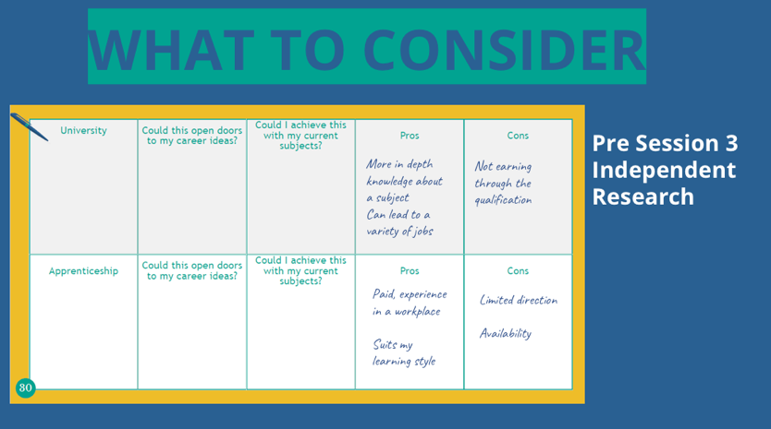

1. THE CONS for you - *different for every pupil*

* University: not earning directly through the qualification

Apprenticeship: limited direction, availability of opportunities

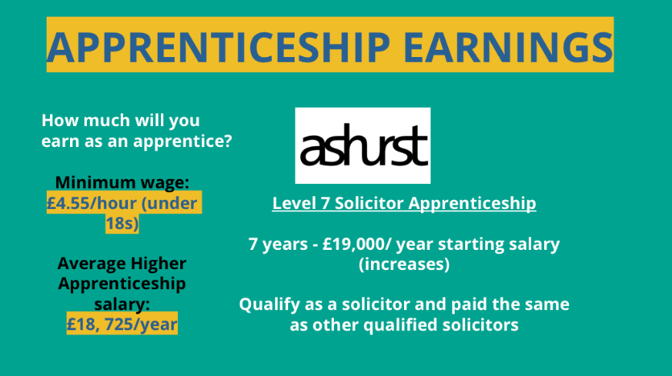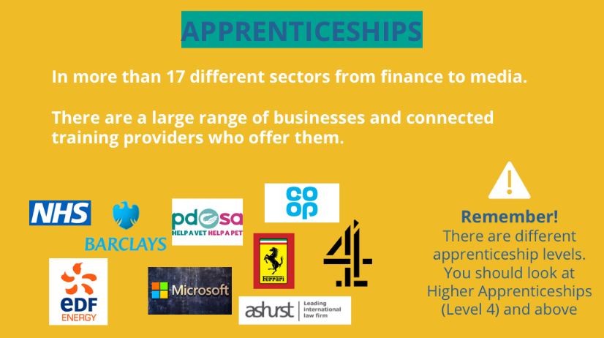

**Apprenticeships**

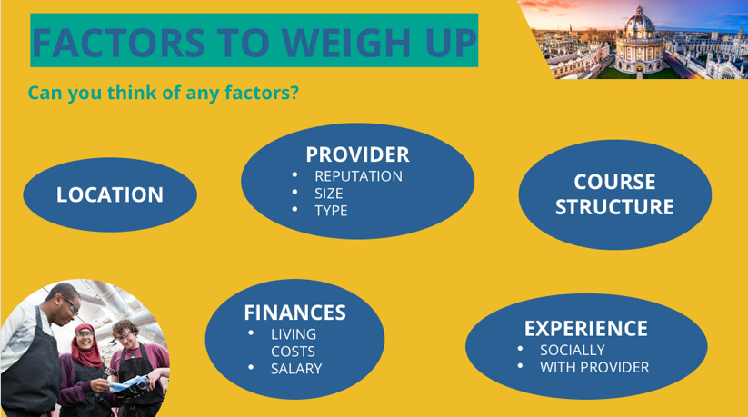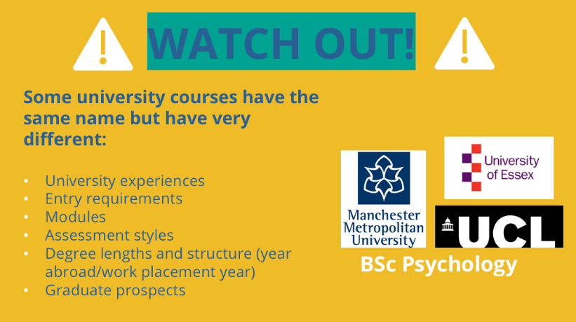

* **Tuition fee loans**: cover the full cost of your course, are paid directly to the course provider, and you won’t have to pay it back until after your course, when you’re earning above a certain level
* **Maintenance loans:** can be applied for at the same time, lending you money at the start of each term (or monthly in Scotland). How much you get depends on your household income, where you study, where you live and how long for
* A big question for students is - how do you pay back the loans?
  + The money comes out of your pay each month (like other taxes), how much you earn determines how much you pay
  + You do not have to repay if your income is below the threshold of £26k. If you earn £27,000/year (before tax) you only pay £3 a month and the figure increases with your salary
  + AFTER 30 YEARS YOUR LOAN BALANCE WILL BE CANCELLED

**University**

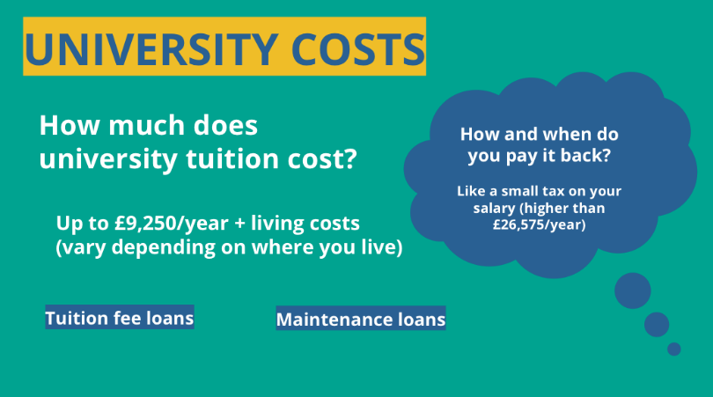

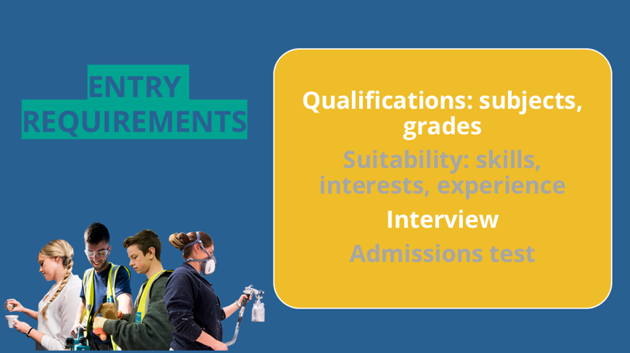

* Universities, colleges and training providers set their own entry requirements for higher education courses, and these vary widely.
* They set the entry requirements for courses to ensure you have the right skills and knowledge to successfully complete the course.
* Subjects and exam grades – usually GCSE grades, A levels/ equivalent qualifications, (sometimes converted to UCAS Tariff points).
* Your suitability – course descriptions often mention skills, interests, or experience it’s good to have
* An interview – sometimes universities and employers will want to meet you in person or speak to you over the phone. It will be worth doing some early preparation.
* An admissions test – occasionally employers and universities will want to do their own assessment.
* **The way to make sure that you get into the provider you want is to create a fantastic application.**

**Financial support at University**

* **Bursaries** are usually awarded to students based on their personal circumstances and cover some living costs (as a one-off payment)
* **University scholarships** usually reward students who are outstanding in their subject, sport or music. They generally (but not always) need to be applied for, and are often competitive. They provide cover for some living costs or tuition fees.
* Universities offer **student financial support** - it’s worth looking at the page on the individual universities you are interested in as they have dedicated pages on their website.
* **Part time job** - this is a great option to gain some money to help with living costs. Some of you may already have one n

**Application timeline**

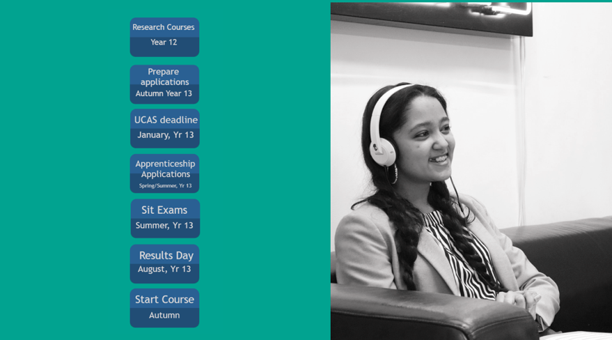

* All the deadlines for university/apprenticeships can be found on the provider website/UCAS
* If you’re in Year 13 and still unsure about whether you want to go to university, apply now - you can defer/decline offers later but it’s always better to have options
* Apprenticeship applications start slightly later in the year
* If you’re in Year 12 you still have a year before you need to apply
* Keep these timelines in mind so you’ll be super prepared for when the deadlines come up.

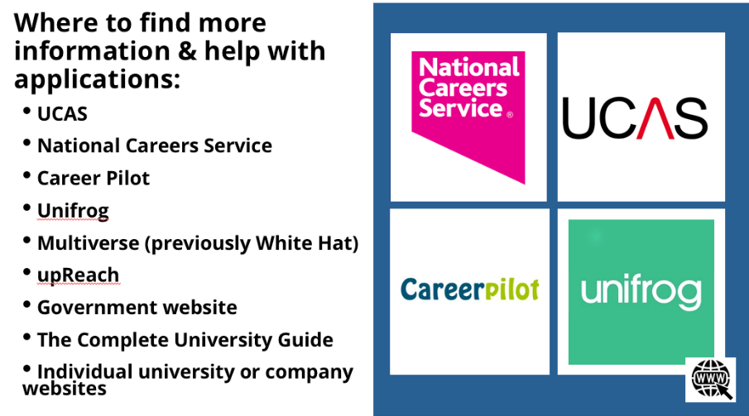

**There are loads of amazing resources to help you - here are a few that you can use with your coach in the coming week:**

* **UCAS**
* **National Careers Service** – support with completing apprenticeship, job applications, writing CVs
* **Career Pilot/Unifrog**
* **Multiverse** **(previously White Hat)** – matching apprentices up with companies and helping with the application process
* **upReach** - help young people from lower income families access different career pathways
* **The Complete University Guide –** next steps/key dates
* **Government website** – lots of information on available apprenticeships and case study examples