INDEPENDENT RESEARCH BEFORE SESSION 2: CREATE A CAREER PILOT ACCOUNT & CREATE YOUR JOB SECTOR SHORTLIST

Career Pilot is a useful website to use when researching careers, qualifications and pathways. You will be using this to help create your job sector shortlist. It should only take a few minutes to set up your account.
Where it asks you for your school name type and select “Future Frontiers UK”

- Register on career pilot here: https://www.careerpilot.org.uk/register
  - Fill in your details – using the prompts on this page.

2) You can now access your account whenever you want to!
Before session 2 you need to fill in the career sector quiz, but you can use this website in your own time too to build a profile and find out more about careers and pathways.
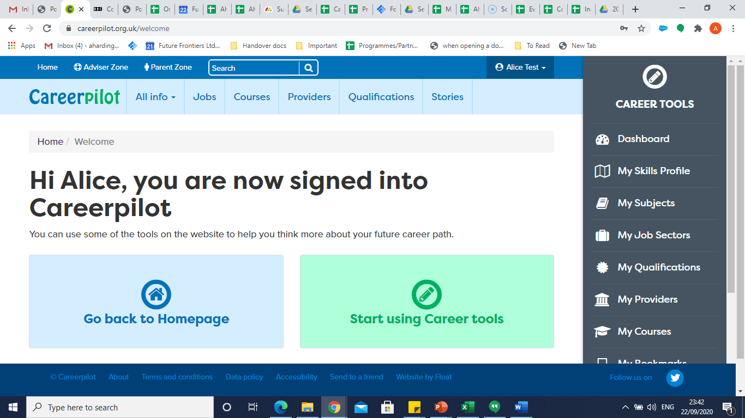
3) Log onto Career Pilot: https://www.careerpilot.org.uk ,
click on “My job sectors” on the right bar and take the Job Sector Quiz to explore what sectors you are best matched to.

4) Note down the top 3 sectors you are best matched with on the next page.

5) Complete your Job Sector shortlist using the Job Sector quiz and researching the related job profiles on Career Pilot to help you find careers within each sector.
Well done!
You’re ready for Session 2 with your coach.
Careers I am interested in within this sector:
1.

2.

3.
My Top Sector is:
My Second Sector is:
My Third Sector is:
Careers I am interested in within this sector:
1.

2.

3.
Careers I am interested in within this sector:
1.

2.

3.

